# Lab: Functions, Objects and Classes

This document defines a set of tasks to be done as a part of the "[PHP Web Development Basics - 2018](https://softuni.bg/trainings/2163/php-web-development-basics-september2018#lesson-9663).

You can check your solutions here: <https://judge.softuni.bg/Contests/466/Functions-Objects-and-Classes-Lab>.

# Part I: Functions

## Symmetry Check

Write a function **isPalindrome** to check a string for symmetry.

### Examples

|  |  |
| --- | --- |
| **Input** | **Output** |
| abcccba | true |
| xyz | false |

## Day of Week

Write a function to return the day number by day of week in text.

### Examples

|  |  |
| --- | --- |
| **Input** | **Output** |
| Monday | 1 |
| Sunday | 7 |
| Hi | Invalid day! |

## Inside Volume

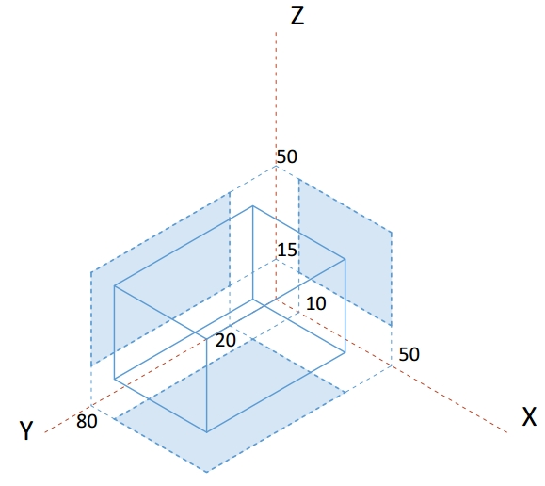Write a function that determines whether a point is inside the volume, defined by the box, shown on the right.

The **input** comes as a string representing the coordinates that needs to be split and parsed as numbers. Each set of 3 elements are the x, y and z coordinates of a point.

The **output** should be printed to the console on a new line for each point. Print inside if the point lies inside the volume and outisde otherwise.

### Examples

|  |  |
| --- | --- |
| **Input** | **Output** |
| 8, 20, 22 | outside |
| 13.1, 50, 31.5, 50, 80, 50, -5, 18, 43 | inside  inside  outside |

### Hints

This task is very similar to previous assignments where a point might lie inside an area in 2D space, with just an extra dimension added. If we look at a classic conditional statement, which checks whether a point is inside a rectangle:

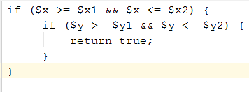

It checks whether a coordinate is greater than the minimum and at the same time less than the maximum bounding value for both axes (x and y). All we have to do is to include an additional check for a coordinate to be within the vertical limits of the volume (z-axis):

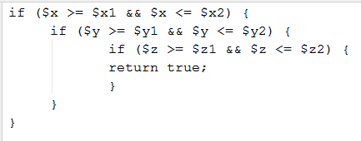

We can then wrap this whole statement in a function and as we process each set of coordinates, pass them to see if they are inside the volume and print the correct message to the console. Since the volume is the same every time, we can hardcode the values, but it’s generally good practice to pass them as function arguments, so that the function may work with any arbitrary volume. Later in the course we’ll learn how to shorten this with the use of objects.

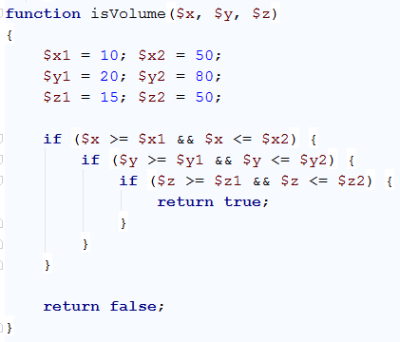

We can extract the sets of coordinates with a loop that skips 3 elements at a time and assigns them to temporary variables:

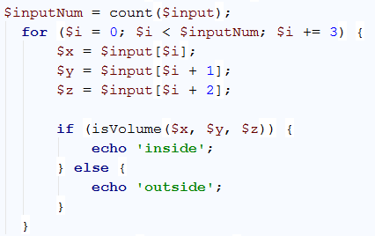

We know from the problem description that the input array will contain sets to three coordinates. Starting at 0, the current element (denoted by index ***i*** inside the loop) is the x-coordinate, the element after the current (***i + 1***) is the y-coordinate, and the element two indices after the current (***i + 2***) is the z-coordinate. At the end of the cycle, the index is increased by 3 and we can obtain the coordinates of the next point, using the same arithmetic (instead of 0, 1 and 2 we will get 3, 4 and 5) and so on, until there are no more elements in the array. The three coordinates are passed into our function and we get a Boolean value as a result. If it’s true, we print inside for the current point and otherwise we print outside.

## Road Radar

Write a function that determines whether a driver is within the speed limit. You will receive his speed and the area where he’s driving. Each area has a different limit: on the **motorway** the limit is **130** km/h, on the **interstate** the limit is **90**, inside a **city** the limit is **50** and within a **residential** area the limit is **20** km/h. If the driver is within the limits, your function prints nothing. If he’s over the limit however, your function prints the severity of the infraction. For speeds up to **20** km/hover the limit, he’s speeding; for speeds up to **40** over the limit, the infraction is **excessive speeding** and for anything else, **reckless driving**.

The **input** comes in two rows. On the first row you will receive the current speed as a string and needs to be parsed as a number. On the second row you will be given the second element which is the area.

The **output** should be printed to the console. Note in certain cases there will be no output.

### Examples

|  |  |
| --- | --- |
| **Input** | **Output** |
| 40  city |  |
| 20  residential | speeding |
| 120  interstate | excessive speeding |
| 200  motorway | reckless driving |
| 50  city | speeding |

### Hints

We can divide the task in two functions – one that determines what the current speed limit is, depending on zone, and another which tells us if an infraction is being made, depending on current speed and current limit. Determining the limit is achieved with a **switch** statement on the input:

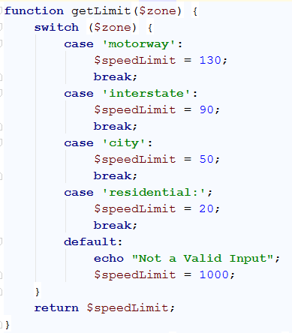

This function takes a string as an argument and returns a number, depending on what that string is. We can take this directly from the input, pass it to this function and save the return value in a variable. In our second function, we pass the current speed and the limit, which we just saved.

## *Template format

Write a program that receives data about a quiz and prints it formatted as an XML document. The data comes as pairs of question-answer entries. The format of the document should be as follows:

|  |
| --- |
| **XML** |
| <?xml version="1.0" encoding="UTF-8"?>  <quiz>  <question>  {question text}  </question>  <answer>  {answer text}  </answer>  </quiz> |

The **input** comes as a string in which the questions and answers will be separated by “, “.

The **output** should be printed on the console.

### Examples

|  |
| --- |
| **Input** |
| Who was the forty-second president of the U.S.A.?, William Jefferson Clinton |
| **Output** |
| <?xml version="1.0" encoding="UTF-8"?>  <quiz>  <question>  Who was the forty-second president of the U.S.A.?  </question>  <answer>  William Jefferson Clinton  </answer>  </quiz> |

|  |
| --- |
| **Input** |
| Dry ice is a frozen form of which gas?, Carbon Dioxide, What is the brightest star in the night sky?, Sirius |
| **Output** |
| <?xml version="1.0" encoding="UTF-8"?>  <quiz>  <question>  Dry ice is a frozen form of which gas?  </question>  <answer>  Carbon Dioxide  </answer>  <question>  What is the brightest star in the night sky?  </question>  <answer>  Sirius  </answer>  </quiz> |

# Part II: Objects and Classes

## Person

Define a class **Person** with fields for **name** and **age**.

### Note

Add the following code and submit it to Judge.

|  |
| --- |
| $person = new Person();  echo(count(get_object_vars($person))); |

The output on the console should be **2**. If you defined the class correctly, the test should pass.

### Bonus*

Try to create a few objects of type Person:

|  |  |
| --- | --- |
| **Name** | **Age** |
| Pesho | 20 |
| Gosho | 18 |
| Stamat | 43 |

## Creating Constructor

Add constructor to the **Person** class from the last task:

1. It should accept a string for the name and an integer for the age and should produce a person with the given name and age.

Add the following code to your main method and submit it to Judge.

|  |
| --- |
| public function __construct(string $name, int $age) {  $this->name = $name;  $this->age = $age;  echo $this->name . " " . $this->age;  } |

If you defined the constructors correctly, the test should pass.

The **input** comes in two rows. On the first row you will receive the name. On the second row you will be given the age.

The **output** should be printed to the console as single line - name and age separated with one space

### Examples

|  |  |
| --- | --- |
| **Input** | **Output** |
| Pesho  20 | Pesho 20 |
| Gosho  18 | Gosho 18 |
| Stamat  43 | Stamat 43 |

## Print People

Create a class **Person**. Every person should have name, age and occupation. Your task is to create the class and read some people, while adding them to an array. Sort them by age and print them in the given format.

### Examples

|  |  |
| --- | --- |
| **Input** | **Output** |
| Gosho 22 Dentist  Mimi 13 Student  END | Mimi - age: 13, occupation: Student  Gosho - age: 22, occupation: Dentist |

## Method Says Hello!

You will receive the person name as an input. Write a class **Person** that only has a name and a **method**. The method should describe a greeting by the person, returning a String "<Person name> says Hello!". Print the result of the method call.

### Note

Code sample.

|  |
| --- |
| $name = trim(fgets(STDIN));  $person = new Person($name);  $fields = count(get_object_vars($person));  $methods = count(get_class_methods($person)); **if** ($fields!= 1 || $methods != 1) {  **throw new** Exception(**"Too many fields or methods"**); } |

### Examples

|  |  |
| --- | --- |
| **Input** | **Output** |
| Peter | Peter says "Hello"! |